**Visualizing MNIST – An Exploration of Dimensionality Reduction**

**Introduction:**

The MNIST dataset, consisting of handwritten digits, is a widely used benchmark in the field of machine learning. In this project, we aim to explore and implement dimensionality reduction techniques to visualize the MNIST dataset effectively. Dimensionality reduction is crucial for simplifying complex datasets while retaining essential information, making it easier to analyze and interpret.

**Objectives:**

* Apply various dimensionality reduction techniques to the MNIST dataset.
* Visualize the reduced-dimensional representations of handwritten digits.
* Evaluate the effectiveness of different dimensionality reduction methods in preserving essential features.
* Compare and contrast the visualizations obtained through different techniques.

**Methodology:**

**Dataset Preparation:**

* Download and preprocess the MNIST dataset. Ensure proper data cleaning and formatting for subsequent analysis.

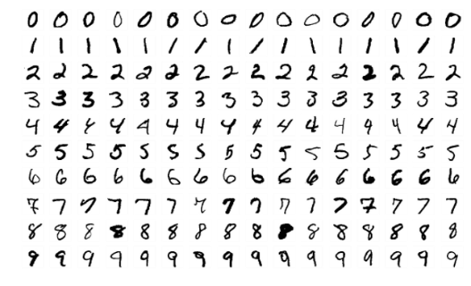

* For a pair of MNIST data points, xi and xj, two distinct distance measures exist between them. One is the distance in the original space, denoted as d∗i,j, and the other is the distance in our visualization, denoted as di,j. The cost function C is defined as the sum of squared differences between these distances for all distinct pairs:

*C*=∑*i*=*j*​(*d*∗*i*,*j*−*di*,*j*)2

* The value of the defined cost function serves as a measure of the quality of a visualization. Essentially, it conveys the notion that deviating distances, especially in a quadratic manner, indicates a suboptimal visualization. A higher value signifies significant dissimilarity from the original space, while a smaller value indicates similarity. An ideal scenario is represented by a zero value, signifying a flawless embedding where distances perfectly align with the original space.

**Dimensionality Reduction Techniques:**

Implement the following dimensionality reduction techniques:

* Principal Component Analysis (PCA)
* t-Distributed Stochastic Neighbor Embedding (t-SNE)
* Uniform Manifold Approximation and Projection (UMAP)

**Visualization:**

Generate visualizations of the reduced-dimensional representations using the chosen techniques. Utilize color coding or labeling to distinguish between different digits.

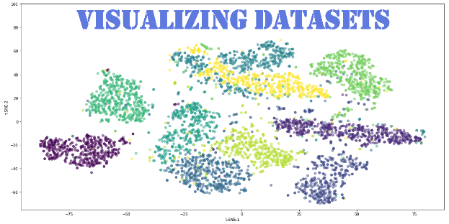

**Evaluation:**

* Quantitatively evaluate the performance of each dimensionality reduction technique. Metrics may include information preservation, clustering quality, and computational efficiency.
* Imagine a nearest neighbor graph for MNIST, represented as a graph (V, E) where nodes correspond to MNIST data points. Each node is connected to its three closest neighbors in the original space, forming edges. This graph serves as a simplified representation of local structure while disregarding other aspects.
* With such a graph in place, standard graph layout algorithms, specifically force-directed graph drawing, can be employed for MNIST visualization. In this approach, each point is treated as a repelling charged particle, and the edges act like springs. The corresponding cost function is given by:

*C*=∑*i*=*j*​*di*,*j*​1​+21​∑(*i*,*j*)∈*E*​(*di*,*j*​−*d*∗*i*,*j*​)2

**Expected Outcomes:**

A set of visualizations illustrating the reduced-dimensional representations of MNIST digits.

Comparative analysis of the effectiveness of different dimensionality reduction methods.

Insights into the trade-offs and advantages of each technique in the context of the MNIST dataset.

**Resources:**

* MNIST dataset
* Python programming language
* Scikit-learn library for dimensionality reduction techniques.
* Matplotlib and Seaborn for data visualization

**Conclusion:**

This project aims to provide a comprehensive exploration of dimensionality reduction techniques in the context of visualizing the MNIST dataset. The outcomes will contribute to a better understanding of the strengths and limitations of each method, aiding researchers and practitioners in choosing the most suitable technique for similar tasks.